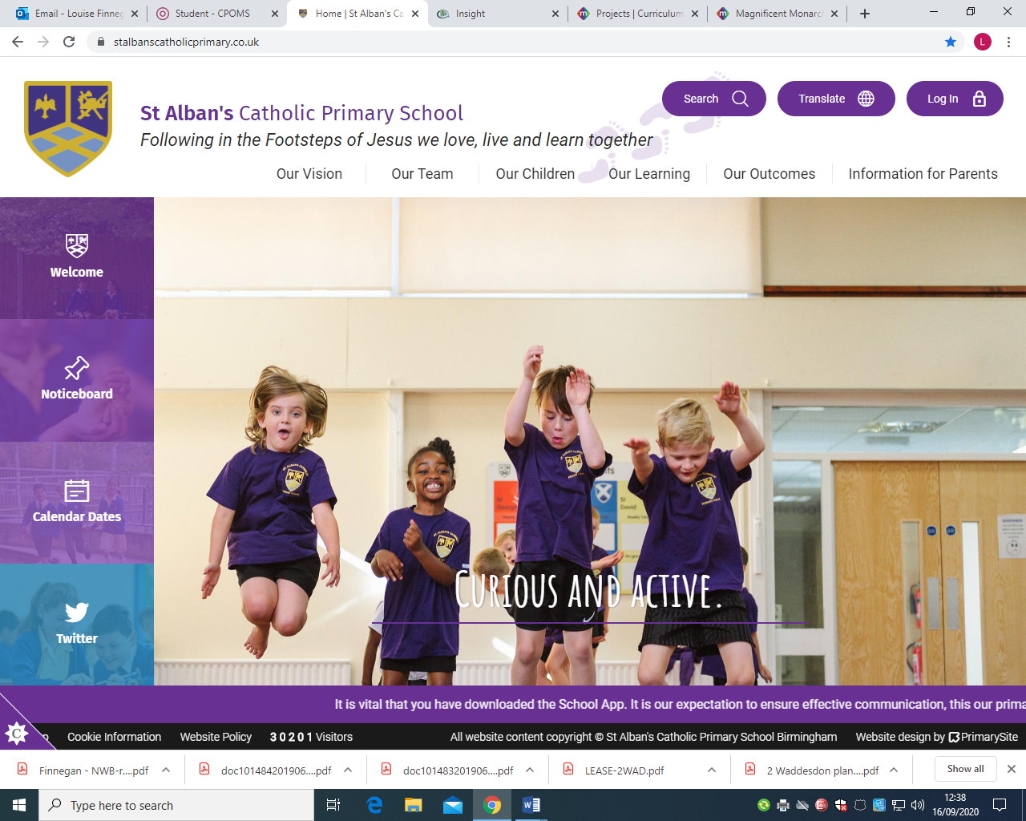
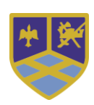

Year Two ~ Curriculum Overview
Autumn Term
Religious Education 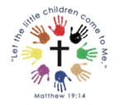 | Our gospel virtues for this term are:  Curious and Active  This term’s topics in RE will be:  • Old Testament Stories and Prayers  • Sharing in the life of Jesus  • Special Celebrations  • Advent  Prayers children will learn:  Our Father  Hail Mary
RSE ~ Life to the Full  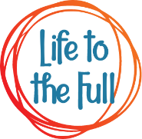 | Module 1: Created and Loved by God  Story Sessions: Handmade with Love  Me, My Body and My Health: I am Unique, Girls and Boys, Clean & Healthy  Emotional Wellbeing: Feelings, Likes and Dislikes, Feelings Inside Out and Super Susie Gets Angry  Life Cycles: The cycle of life
English  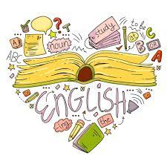 | Read Write Inc.  Through our Read Write Inc. scheme, children will:  Reading:  • Consolidating our sounds and using these to read longer and unfamiliar words  • Draw on background knowledge and use of inference skills to understand books they can already read.  • Learning to read by sight (and develop spelling of) common words that cannot be sounded out such as; children, because, only, should  - Talk Through Stories:  - Story Week: Delve into a story! Exploring the language e.g. favourite phrases  - Vocabulary Week: Children develop an understanding of sophisticated vocabulary (Tier Two) and learn how to use these words in context.  Writing:  • Sequence sentences to form short narratives  Grammar/Punctuation/Spelling:  • Consolidating our knowledge of basic sentence punctuation (capital letters and full stops) alongside building an awareness of question marks and exclamation marks  • Using conjunctions to link ideas in a sentence or move a story on  • Using noun phrases for description  • Consolidate our knowledge of Year One common exception words and begin to learn those from Year 2. Alongside this we will be focusing on using the correct letters to represent a sound
Maths  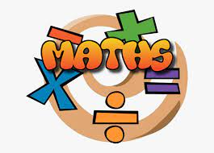 | Place Value  In this unit, children will learn to:  Count objects to 100 by making 10s  Use a place value chart to recognise tens and ones and partition numbers to 100  Write numbers to 100 in words  Count in 10s and 1s on the number line to 100 and estimate numbers on a number line  Compare objects and numbers  Order objects and numbers  Count in 2s, 5s, 10s and 3s  Addition and Subtraction  In this unit, children will learn to:  Recognise number bonds to 10, 20 and 100 and know the related facts  Add and subtract 1s  Add by making 10 first  Add three 1-digit numbers  Add to the next 10  Add and subtract across a 10  Subtract from a 10  Subtract a 1-digit number from a 2-digit number (across a 10)  Know 10 more, 10 less from any given number  Add and subtract two 2-digit numbers (with and without crossing a 10)
Science  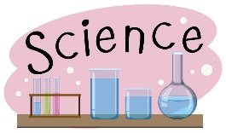 | Living Things in their Environment  The Human Body
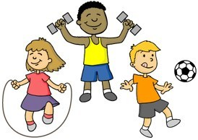  PE | Swimming (Autumn One)
Geography  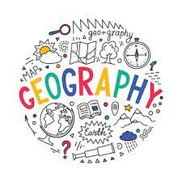 | Spatial Sense (Autumn One)  By the end of this unit, children will know:  • To be able to read and gather information from a simple map  • To be able to draw a simple map  • To understand that maps and globes can show us different areas of the world  • To understand that some maps show small areas and others can show large areas
History  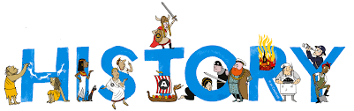 | Romans in Britain (Autumn Two)  By the end of this unit, children will know:  • The Romans were an ancient civilisation that built an empire.  • Romans had well-organised large armies with many soldiers.  • Romans invaded Britain and Boudicca led a rebellion against the Roman invasion.  • Romans built towns across Britain.  • After the fall of the Roman empire, many aspects of Roman life remained in Britain.  • Romans created written records which is why we know about their history.
Art   | Colour and Shape  Artists: Kandinsky, Delaunay, Monet, Klee, Picasso, Calder  Concepts: primary colours, secondary colours, warm and cool colours, tints and shades, geometric shapes, organic shapes  Skills: colour mixing, drawing geometric shapes, using natural objects to draw organic shapes, creating sculptures with paper and wire, working as a team.  Colour, Shape and Texture  Artists: Matisse, Durer, Jan van Eyck  Concepts: cut-outs, complementary colours, organic shapes, composition, visual texture  Skills: colour mixing, selecting complementary colours, cutting organic shapes, creating texture with mark-making and colour, drawing with chalk and charcoal, graphite and oil pastels.
Music  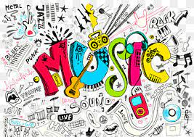 | This term, children will learn about:  Pitch  By the end of this unit, children will:  - Learn what pitch is and how we can recognise high, middle and low sounds.  - Learn about how we can follow the pitch of a piece of music, change the pitch of our singing voices and learn about how we can use both our voices and everyday objects to create high and low sounds.  Contrasts  By the end of this unit, children will:  - Perform and compose rhythmic contrasts in our music making.  - Recognise, perform and compose music that has contrasts in its pitch, articulation and timbre.  - Recognise, perform and compose music that has melodic contrasts and uses dynamic contrasts.
  Spanish | This term, children will learn:  Greetings:  Hello, Goodbye, Good morning, Good afternoon, Good evening, How are you?  Numbers: 0 - 10

