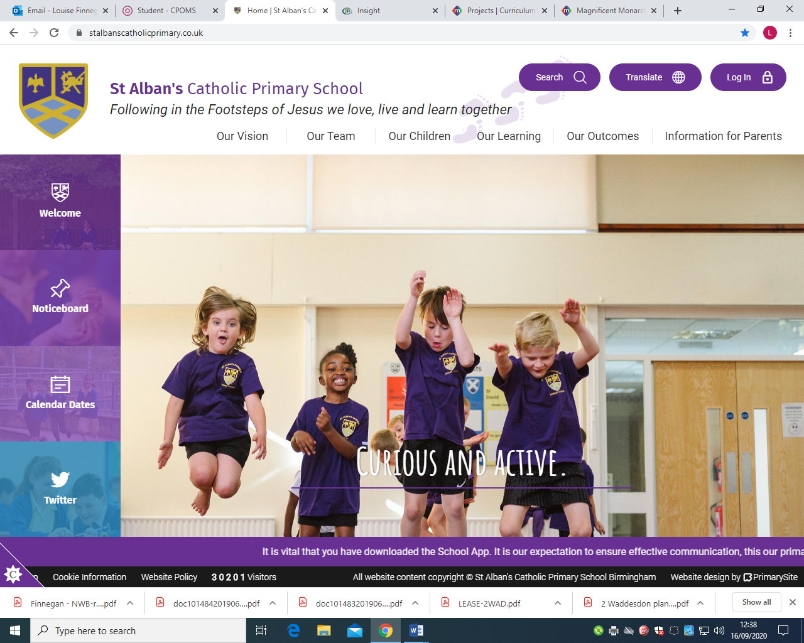
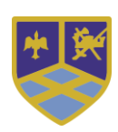

Year Two -Curriculum Overview
Spring Term
Building the Kingdom | Dignity of Work  “The Lord blesses our work so that we may share its fruits with others.”  – Deuteronomy 24:14-15
Big Question | Are some jobs more important than others?  How do we help others find their gifts?
Religious Education  | Our gospel virtues for this term are:  Curious and Active  This term’s topics in RE will be:  • Christmas  • Parables and Miracles  • Special Celebrations  • Lent  Holy Week Prayers children will learn: Our Father, Hail Mary.
Liturgical Dates | 6th January: Epiphany  12th January: The Baptism of the Lord  25th January: Feast of the Conversion of St Paul  2nd February: Feast of the Presentation of the Lord  5th March : Ash Wednesday  13th April: Palm Sunday  17th April: Maundy Thursday  13th -19th April: Holy week  20th April: Easter Sunday
RSE ~ Life to the Full   | Module 2: Created to Love Others  Unit 1 –Religious Understanding: God loves you  Unit 2 – Personal Relationships: Special people, Treat others well…, …and say sorry  Unit 3 – Life Online: Real life online, Rules to help us  Unit 4 – Keeping Safe: Good and bad secrets, physical contact, Harmful substances, Can you help me? (Parts 1 & 2)
English  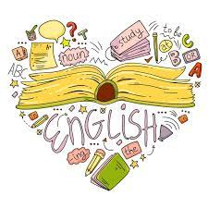 | Read Write Inc.  Through our Read Write Inc. scheme, children will:  Reading:  • Consolidating our sounds and using these to read longer and unfamiliar words  • Draw on background knowledge and use of inference skills to understand books they can already read.  • Learning to read by sight (and develop spelling of) common words that cannot be sounded out such as; children, because, only, should  Writing:  • Sequence sentences to form short narratives Grammar/Punctuation/Spelling:  • Consolidating our knowledge of basic sentence punctuation (capital letters and full stops) alongside building an awareness of question marks and exclamation marks  • Using conjunctions to link ideas in a sentence or move a story on • Using noun phrases for description  • Consolidate our knowledge of Year One common exception words and begin to learn those from Year 2. Alongside this we will be focusing on using the correct letters to represent a sound  Literacy Tree – Writing Roots:  Once children have completed our phonics program, we will explore:  • The Minpins by Roald Dahl  • The Bear and the Piano by David Litchfield  • Tadpole’s Promise by Jeanne Willis Literacy Tree –  Literary Leaves:  As a class, we will be exploring:  • All About Bears by Katie Viggers  • Fanatical About Frogs by Owen Davey  • After the fall by Dan Santat
Maths  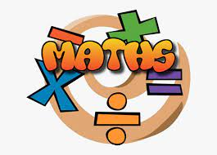 | Money In this unit, children will learn to:  • Count money in pounds and pence  • Identify and select notes and coins  • Make and compare amounts of money  • Calculate with money  Multiplication and Division In this unit, children will learn to:  • Recognise, make and add equal groups  • Recognise the multiplication symbol  • Use arrays  • Make equal groups – grouping  • Make equal groups – sharing  • Know the 2, 5 and 10 times-table  • Doubling, halving and dividing by 2  • Divide by 10 and 5  Money In this unit, children will learn to:  • Count money in pounds and pence  • Identify and select notes and coins  • Make and compare amounts of money  • Calculate with money Multiplication and Division In this unit, children will learn to: • Recognise, make and add equal groups  • Recognise the multiplication symbol  • Use arrays • Make equal groups – grouping  • Make equal groups – sharing  • Know the 2, 5 and 10 times-table  • Doubling, halving and dividing by 2  • Divide by 10 and 5
Science   | Electricity (Spring One) By the end of this unit, children will know:  • Identify things that use electricity  • A battery is a store of electrical energy  • Electricity is energy that we store and use to make things work  • Electricity can be dangerous  • An electrical circuit is a loop that allows electricity to travel around it  • An electrical circuit must have wires and a battery  • If a circuit is broken, electricity will not be able to flow around it  • Materials that allow electricity to pass through them are conductors  • Materials that do not allow electricity to pass through them are insulators  • Many, but not all, metals conduct electricity  Plants (Spring Two) By the end of this unit, children will know:  • There are many different types of plants  • Seeds and bulbs grow into mature plants  • A seed can grow into a flowering plant  • When a seed germinates, it changes from a seed to a seedling  • Some plants create bulbs that live underground, and their leaves grow up through the soil Plants need light and water to grow  • Plants often grow well in the Spring when the temperatures get warmer and there is often rain
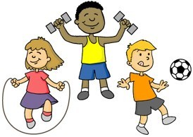  PE | Gymnastics (Spring One) By the end of this unit, children will be able to:  • Rock or roll in a curled shape or long shape  • Make a shape and hold it  • Balance with support from a partner  • Jump  • Copy a movement sequence of two movements  • Get into a plank position  • Perform and describe their movements.  Throwing and Catching (Spring Two) By the end of this unit, children should be able to:  • roll a ball along a line and towards a target, with some success;  • react and stop a rolling ball using two hands;  • throw underarm, using different objects, towards a target with some control;  • throw overarm, using different objects, with some control;  • throw overarm for distance;  • attempt to catch an object, using some of the correct techniques;  • attempt to move and position themselves when trying to catch an object;  • bounce a ball on a spot and occasionally catch it;  • bounce a ball to a partner, changing the height of the bounce;  • use different skills they have learnt in a range of games, with some success;  • evaluate their performance, with support.
Geography  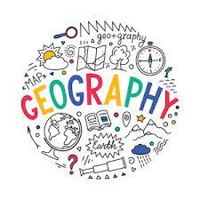 | The British Isles (Spring One) By the end of this unit, children will know:  • The name of different locations within the British Isles on a map.  • How to use maps and atlases to identify locations within the British Isles.  • How to answer geographical questions such as ‘What is it like to live in this place?’
History  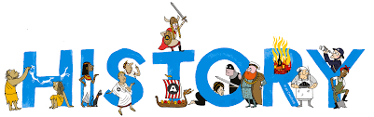 | Romans in Britain (Spring Two) By the end of this unit, children will know:  • The Romans were an ancient civilisation that built an empire.  • Romans had well-organised large armies with many soldiers.  • Romans invaded Britain and Boudicca led a rebellion against the Roman invasion.  • Romans built towns across Britain.  • After the fall of the Roman empire, many aspects of Roman life remained in Britain.  • Romans created written records which is why we know about their history
Art   | Portraits and Self-Portraits Artists:  Leonardo da Vinci, Holbein, Hogarth, Van Gogh, Rembrandt, Kahlo, Picasso, Gentileschi Concepts: Portraits v self-portraits, representation in portraits, proportions of a face, cubism  Skills: Planning and drawing a face, drawing a profile, mixing skin tones, drawing with oil pastels.  Landscape and Symmetry Artists: Constable, Turner, Rousseau, Leonardo da Vinci, Hobbema, Goldsworthy  Concepts: What is a landscape, different methods to paint landscapes, Turner’s style, symmetry in nature and art, temporary art.  Skills: Washes with a sponge, using bold brushstrokes, detailed drawing with oil pastels, creating sculptures with found objects.
Music   | This term, children will learn about:  Pitch  By the end of this unit, children will:  - Learn what pitch is and how we can recognise high, middle and low sounds.  - Learn about how we can follow the pitch of a piece of music, change the pitch of our singing voices and learn about how we can use both our voices and everyday objects to create high and low sounds.  Contrasts  By the end of this unit, children will:  - Perform and compose rhythmic contrasts in our music making.  - Recognise, perform and compose music that has contrasts in its pitch, articulation and timbre.  - Recognise, perform and compose music that has melodic contrasts and uses dynamic contrasts.
  Spanish | This term, children will learn:  Three Kings Day!  Greetings:  Hello, Goodbye, Good morning, Good afternoon, Good evening, How are you?  Numbers: 0 – 10  We will celebrate Three Kings Day on the 6th January!

