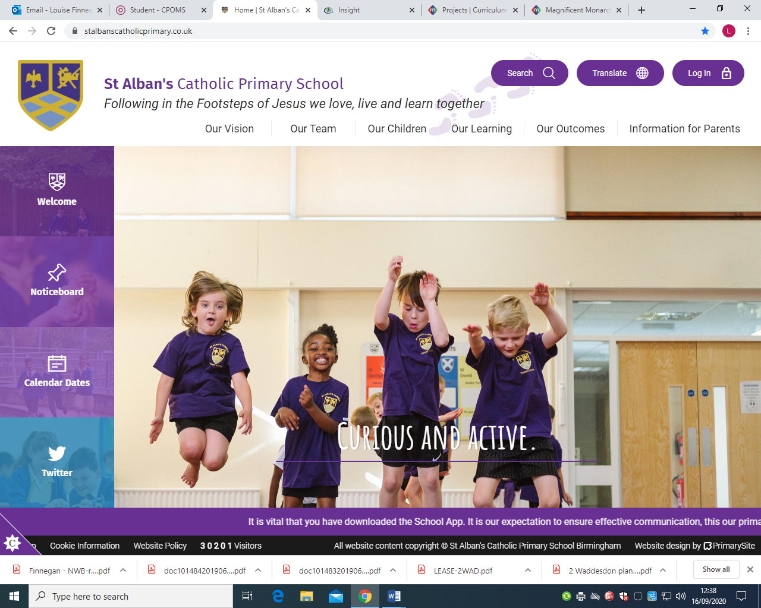
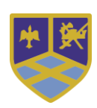

Year Two -Curriculum Overview
Summer Term
Building the Kingdom | Solidarity and the Common Good “If one member of Christ’s body suffers, all suffer. If one member is honoured, all rejoice.” – 1 Corinthians 12:12-26
Big Question | What does Jesus mean when he says we are ‘brothers and sisters’?  Who needs our help?
Religious Education 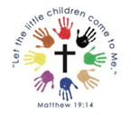 | Our gospel virtues for this term are:  Our gospel virtues for this term are: Compassionate & Loving Faith-filled & Hopeful  This term’s topics in RE will be:  • Easter  • Pentacost  • Special Celebrations
Liturgical Dates | Thursday 29 May - Solemnity of The Ascension of the Lord – Holy Day of Obligation Sunday 8 June - Solemnity of Pentecost Sunday 15 June - Solemnity of The Most Holy Trinity Sunday 22 June - Solemnity of The Most Holy Body and Blood of Christ Tuesday 24 June - Nativity of St. John the Baptist Friday 27 June Solemnity of The Most Sacred Heart of Jesus Sunday 29 June - St. Peter and St. Paul - Holy Day of Obligation
RSE ~ Life to the Full   | Module 2: Created to Love Others  Unit 1 –Religious Understanding: God loves you  Unit 2 – Personal Relationships: Special people, Treat others well…, …and say sorry  Unit 3 – Life Online: Real life online, Rules to help us  Unit 4 – Keeping Safe: Good and bad secrets, physical contact, Harmful substances, Can you help me? (Parts 1 & 2)
English  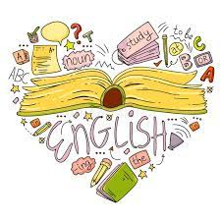 | Read Write Inc.  Through our Read Write Inc. scheme, children will:  Reading:  • Consolidating our sounds and using these to read longer and unfamiliar words  • Draw on background knowledge and use of inference skills to understand books they can already read.  • Learning to read by sight (and develop spelling of) common words that cannot be sounded out such as; children, because, only, should  Writing:  • Sequence sentences to form short narratives Grammar/Punctuation/Spelling:  • Consolidating our knowledge of basic sentence punctuation (capital letters and full stops) alongside building an awareness of question marks and exclamation marks  • Using conjunctions to link ideas in a sentence or move a story on • Using noun phrases for description  • Consolidate our knowledge of Year One common exception words and begin to learn those from Year 2. Alongside this we will be focusing on using the correct letters to represent a sound  Literacy Tree – Writing Roots:  Once children have completed our phonics program, we will explore:  • Tadpole’s Promise by Jeanne Willis Literacy Tree  The Dragon Machine  The Great Fire of London  Literary Leaves:  As a class, we will be exploring:  • All About Bears by Katie Viggers  • Fanatical About Frogs by Owen Davey
Maths  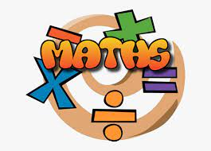 | Fractions In this unit, children will learn to:  Introduction to parts and whole  Step 2 Equal and unequal parts  Step 3 Recognise a half  Step 4 Find a half  Step 5 Recognise a quarter  Step 6 Find a quarter  Step 7 Recognise a third  Step 8 Find a third  Step 9 Find the whole  Step 10 Unit fractions  Step 11 Non-unit fractions  Step 12 Recognise the equivalence of a half and two-quarters  Step 13 Recognise three-quarters  Step 14 Find three-quarters  Step 15 Count in fractions up to a whole  Time In this unit, children will learn to:  Step 1 O’clock and half past  Step 2 Quarter past and quarter to  Step 3 Tell the time past the hour  Step 4 Tell the time to the hour  Step 5 Tell the time to 5 minutes  Step 6 Minutes in an hour  Step 7 Hours in a day
Science  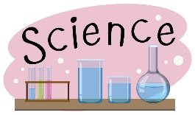 | Materials By the end of this unit, children will know:  • Everyday materials include wood, metal, plastic, glass, brick, rock, paper and cardboard. • Every material has its own properties – these can include being hard, soft, opaque, shiny, bendy.  • Materials are used for a purpose depending on their properties.  • Inventors need to think about the best materials to use for their inventions.  • Scientists use a microscope to look closely at very small things.  • Sometimes, materials look very different when we look at using a microscope.  • Everything around us is made from tiny building blocks we cannot see called particles.  • Solids have a definite shape.  • The shape of some solids can be changed by squashing, bending, twisting and stretching. • The particles in a solid are tightly packed together and have a strong bond.  • Liquids can be poured.  • The shape of a liquid depends on the container it is being held in.  • Water can be a solid and can also be a liquid.  Astrology By the end of this unit, children will know:  • The Sun is a star at the centre of our solar system.  • There are eight planets in our solar system: Mercury, Venus, Earth, Mars, Jupiter, Saturn, Uranus and Neptune.  • Planets travel around the Sun. We call this journey an orbit.  • As the planets orbit the Sun, they also spin around. We call this rotation.  • Night and day occur due to the Earth rotating.  • The Moon orbits the Earth.  • The Moon reflects the light of the Sun.  • As the Moon’s position changes, we can see different parts of it.  • A constellation is a group of stars that, when seen from Earth, form a pattern.  • People have given constellations names and have told stories that imagine how the constellations were formed.  • Astronomers have studied the stars for many years, learning from each other and making new discoveries.
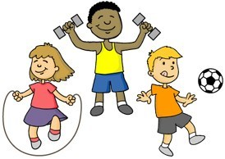  PE | Gymnastics By the end of this unit, children will be able to:  • Rock or roll in a curled shape or long shape  • Make a shape and hold it  • Balance with support from a partner  • Jump  • Copy a movement sequence of two movements  • Get into a plank position  • Perform and describe their movements.  Throwing and Catching By the end of this unit, children should be able to:  • roll a ball along a line and towards a target, with some success;  • react and stop a rolling ball using two hands;  • throw underarm, using different objects, towards a target with some control;  • throw overarm, using different objects, with some control;  • throw overarm for distance;  • attempt to catch an object, using some of the correct techniques;  • attempt to move and position themselves when trying to catch an object;  • bounce a ball on a spot and occasionally catch it;  • bounce a ball to a partner, changing the height of the bounce;  • use different skills they have learnt in a range of games, with some success;  • evaluate their performance, with support.
Geography  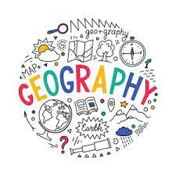 | Northern Europe By the end of this unit, children will know:  • The location of northern Europe means it has quite warm summers and very cold winters.  • Denmark, Norway and Sweden are Scandinavian countries.  • People and animals have adapted to survive the cold winters in Northern Europe
History  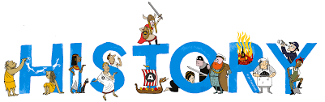 | Tudors (Summer Two) By the end of this unit, children will know:  • Life was different for the rich and the poor in Tudor England • Henry VII was the first Tudor monarch. • Henry VIII made himself Head of the Church of England and had six wives. • Edward VI was a Protestant and made religious reforms during his short reign. • Mary I was a Catholic and is sometimes remembered as ‘Bloody Mary’. • Elizabeth I reigned for 44 years. Her reign is sometimes remembered as the Golden Age
Art   | Portraits and Self-Portraits Artists:  Leonardo da Vinci, Holbein, Hogarth, Van Gogh, Rembrandt, Kahlo, Picasso, Gentileschi Concepts: Portraits v self-portraits, representation in portraits, proportions of a face, cubism  Skills: Planning and drawing a face, drawing a profile, mixing skin tones, drawing with oil pastels.  Landscape and Symmetry Artists: Constable, Turner, Rousseau, Leonardo da Vinci, Hobbema, Goldsworthy  Concepts: What is a landscape, different methods to paint landscapes, Turner’s style, symmetry in nature and art, temporary art.  Skills: Washes with a sponge, using bold brushstrokes, detailed drawing with oil pastels, creating sculptures with found objects.
Music  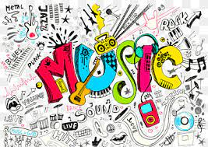 | This term, children will learn about:  Pitch  By the end of this unit, children will:  - Learn what pitch is and how we can recognise high, middle and low sounds.  - Learn about how we can follow the pitch of a piece of music, change the pitch of our singing voices and learn about how we can use both our voices and everyday objects to create high and low sounds.  Contrasts  By the end of this unit, children will:  - Perform and compose rhythmic contrasts in our music making.  - Recognise, perform and compose music that has contrasts in its pitch, articulation and timbre.  - Recognise, perform and compose music that has melodic contrasts and uses dynamic contrasts.
  Spanish | This term, children will learn:  Greetings:  Hello, Goodbye, Good morning, Good afternoon, Good evening, How are you?  Numbers: 0 – 10

