Theme/Term |  | Autumn 1 |  |  |  |  |  |  |  |  |  |  |  |  |  | Autumn 2
Writing Root |  |  | 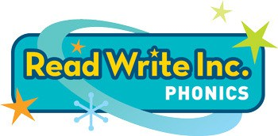
Length
Outcomes
RWInc. -  Talk through Stories  Whole Class |  | 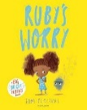  Ruby’s Worry by Tom Percival |  | 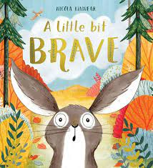  A Little Bit Brave  By Nicola Kinnear |  | 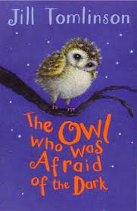  The Owl who was afraid of the dark  by Jill Tomlinson |  |  | 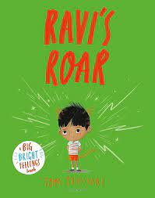  Ravi’s Roar by Tom Percival |  | 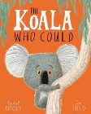  The Koala Who Could  by Rachel Bright |  | 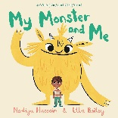  My Monster and me by Nadiya Hussain and Ella Bailey | 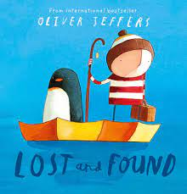  Lost & Found  by Oliver Jeffers | 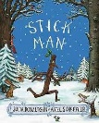  Stick Man  by Julia Donaldson |  | 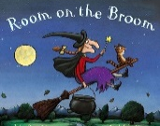  Room on the Broom  by Julia Donaldson | 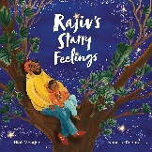  Rajiv’s starry feelings by Niall Moorjanj and Nanette Regan |  | 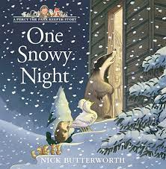  One Snowy Night  by Nick Butterworth |  | 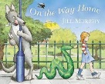  On the way home  by Jill Murphy
Squiggle whilst you wiggle
Whole class fine motor intervention

Theme/Term |  | Spring 1 |  |  |  |  |  |  | Spring 2
Writing Root
Length
Outcomes
RWInc. -  Talk through Stories  Whole Class |  | 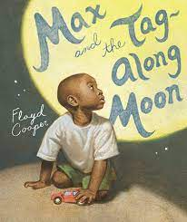  Max and the tag-along moon  By Floyd Cooper |  | 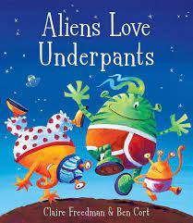  Aliens love underpants  By Claire freedman and Ben Cort |  | 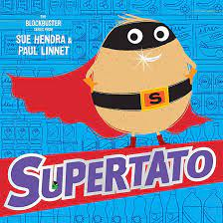  Supertato  by Sue Hendra and Paul Linnet |  | 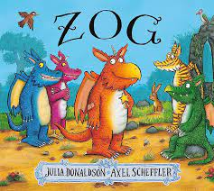  Zog  By Julia Donaldson | 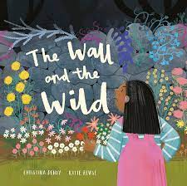  The Wall and the Wild by Christina Dendy |  | 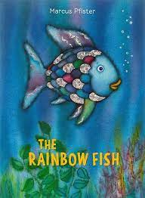  The Rainbow Fish  By Marcus  Pfister | 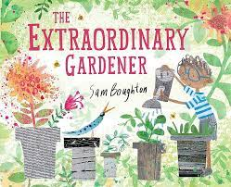  The extraordinary Gardener by Sam Boughton |  |  | 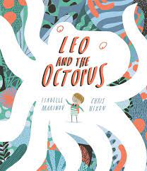  Leo and the Octopus  By Isabelle Marinow
Drawing club
3 x 30 minute sessions a week
Linked to Talk throught stories book

Theme/Term |  | Summer 1 |  |  |  |  |  |  | Summer 2
Writing Root
Length
Outcomes
RWInc. -  Talk through Stories  Whole Class |  | 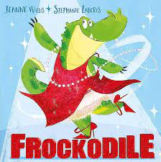  Frockodile by Jeanne Willis | 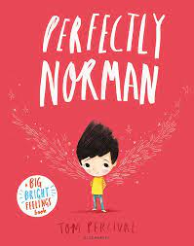  Perfectly Norman  by Tom Percival | 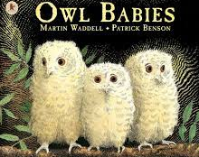  Owl Babies by Martin Waddell and Patrick Benson | 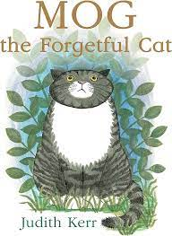  Mog the forgetful cat  By Juidth Kerr |  | 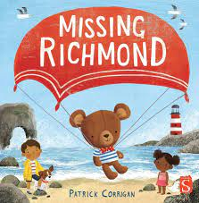  Missing Richmond by Patrick Corrigan | 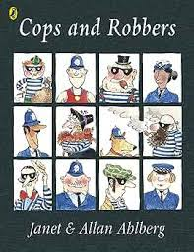  Cops and Robbers  By Janet and Allan Ahlberg | 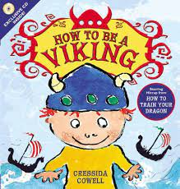  How to be a Viking by Cressida Cowell |  |  | 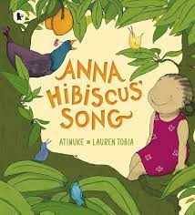  Anna Hibiscus’ Song by Atinuke | 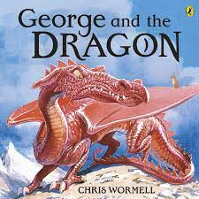  George and the Dragon  By Chris Wormell |  | 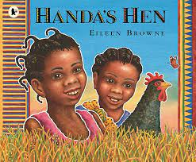  Handa’s Hen  By Eileen Browne | 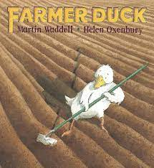  Farmer Duck  by Martin Waddell and Helen Oxenbury | 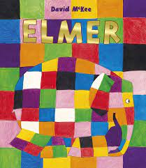  Elmer  By David Mckee
Drawing club
3 x 30 minute sessions a week
Linked to Talk throught stories book

