Reception  Lily and the Polar Bears  Jion Sheibani | 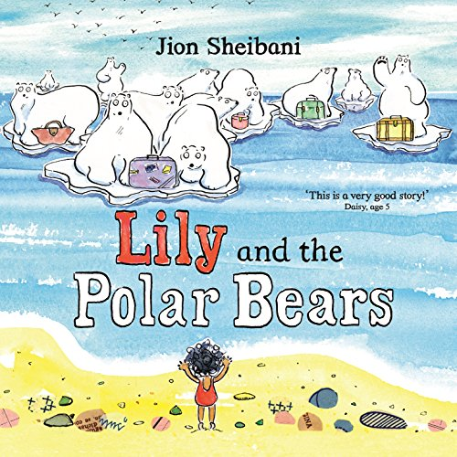
Year 1  My name is not refugee  Kate Milner  The Silence Seeker  Ben Morley | 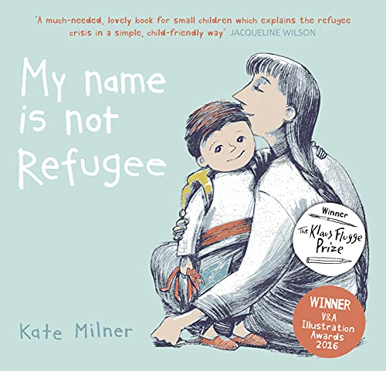  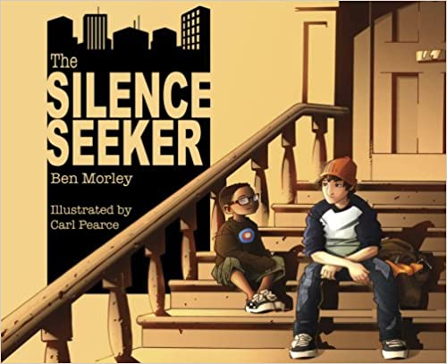
Year 2  The Journey  Francesca Sanna | 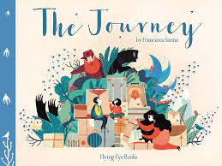
Year 3  Wisp – A story of hope  Zana Fraillon and Grahame Baker Smith | 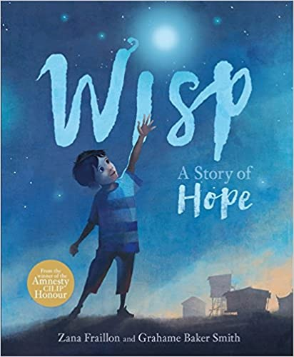
Year 4  Azzi In Between  Sarah Garland | 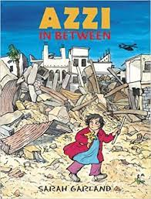
Year 5  The Colour of Home  Mary Hoffman | 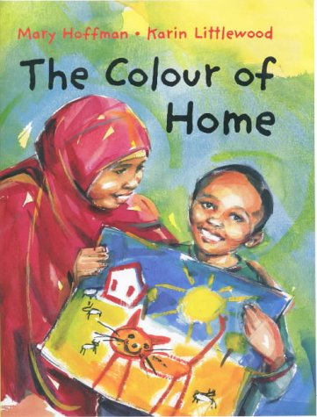
Year 6  Who are Refugees and migrants? What makes people leave their homes? And other big questions.  Michael Rosen and Annmarie Young | 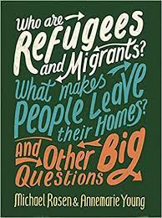

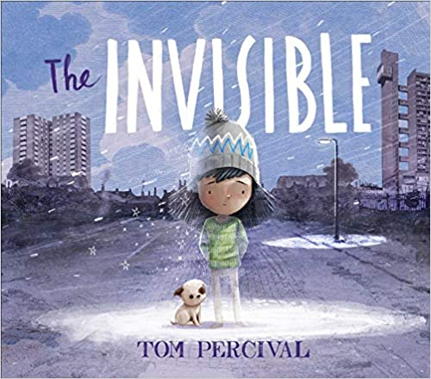
Whole School Book

The Invisible
Tom Percival

