Theme/Term |  | Autumn 1 |  |  |  |  |  |  |  | Autumn 2
Writing Root |  | 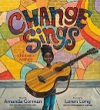 |  | Change Sings by  Amanda Gorman | 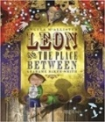 | Leon and the Place Between  by Angela McAllister |  | 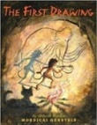 | The First Drawing by  Mordicai Gerstein | 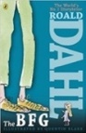 | The BFG by Roald Dahl |  | 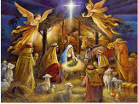 | RE through Literacy: Christmas
Length |  | 2 weeks |  |  | 3 weeks |  |  | 2 weeks |  | 4 weeks |  |  | 2 weeks
Outcomes |  | Genres covered: Instructions, poetry, biographies, celebrating uniqueness, slogans and posters. |  |  | Main Outcome: Own version fantasy narratives  Other genres covered: Persuasive posters, setting descriptions, thought bubbles/diaries, dialogue |  |  | Main Outcome: Own historical narratives  Other genres covered:  Character descriptions, diaries, recounts |  | Main Outcome: Own version fantasy narratives  Other genres covered: Recount (diary entry), character descriptions, wanted posters, new chapters, instructions |  |  | Main Outcome:  Mythical narratives  Other genres covered:  Odes, soliloquies, setting descriptions, additional chapters, reports
Literary Leaf Text |  | 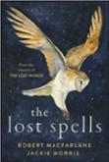 | The Lost Spells by  Robert MacFarlane |  |  |  | 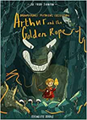 | Arthur and the Golden Rope by Joe Todd Stanton |  | 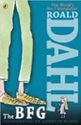 |  | The BFG by Roald Dahl
Length |  | 3 weeks |  |  |  |  | 3 weeks |  |  | 6 weeks

Theme/Term |  | Spring 1 |  |  |  | Spring 2
Writing Root |  | 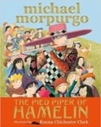 | The Pied Piper of Hamelin by Michael Morpurgo | 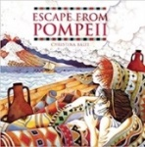 | Escape from Pompeii  by Christina Balit | 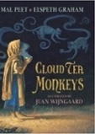 |  | Cloud Tea Monkeys  by Mal Peet & Elspeth Graham | 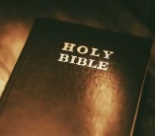 | RE through Literacy: Holy Week
Length |  | 3 weeks |  | 3 weeks |  | 3 weeks |  |  | 2 weeks
Outcomes |  | Main Outcome: Own version myths/legends  Other genres covered:  Writing in role, information reports, adverts, formal letters |  | Main Outcome: Newspaper reports  Other genres covered:  Setting descriptions, diaries, letters, thought bubbles |  | Main Outcome: Non-chronological reports  Other genres covered: Descriptions, ‘how to’ guides (instructions), letters, discussions |  |  | Main Outcome: Diary entry  Other genres covered: Witness statement.
Literary Leaf Text |  | 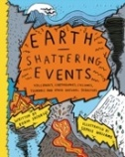 | Earth Shattering Events by Robin Jacobs |  |  | 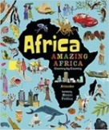 | Africa, Amazing Africa by Atinuke
Length |  | 5 weeks |  |  |  | 5 weeks

Theme/Term |  | Summer 1 |  |  |  |  | Summer 2
Writing Root |  | 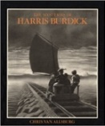 |  | The Mysteries of Harris Burdick by Chris Van Allsberg | 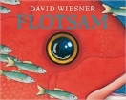 | Flotsam by David Wiesner | 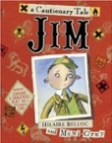 | Jim, A Cautionary Tale  by Hilaire Belloc | 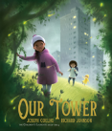 |  | Our Tower by Joseph Coelho
Length |  | 3 weeks |  |  | 3 weeks |  | 3 weeks |  | 3 weeks
Outcomes |  | Main Outcome: Extended fantasy narrative  Other genres covered:  Setting description, short first person narrative, dialogue, speech, action scene |  |  | Main Outcome: Sequels (mystery narratives) Other genres covered:  Postcards, setting descriptions, non-chronological reports, message in a bottle letters |  | Main Outcome: Narrative poems  Other genres covered:  Warning posters, warning announcements, alternative endings, performance poetry, letters of apology |  | Main Outcome: Extended fantasy narratives  Other genres  Poems, setting descriptions, diary entries, dialogue, letters of thanks
Literary Leaf Text |  | 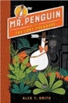 | Mr Penguin and the Lost Treasure by Alex T. Smith |  |  |  | 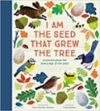 | I am the Seed that Grew the Tree  by Fiona Waters | 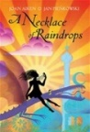 | A Necklace of Raindrops  by Joan Aiken
Length |  | 6 weeks |  |  |  |  | 3 weeks |  | 3 weeks

