Theme/Term |  | Autumn 1 |  |  |  |  |  | Autumn 2
The Write Stuff Units |  | 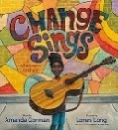 | Change Sings by  Amanda Gorman |  | 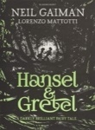 | Hansel and Gretel  by Neil Gaiman | 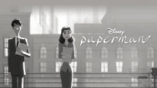  Paperman (Animation) |  | Everest by Sangma Francis & Lisk Feng |  | 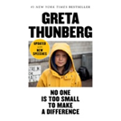 | No one is too small to make a difference by Greta Thunberg | 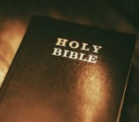 | RE through Literacy: Advent
Length |  | 2 weeks |  |  | 3 weeks |  | 3 weeks | 2 weeks |  |  | 3 weeks |  | 2 weeks
Outcomes |  | Main Outcome: Narrative and Poetry |  |  | Main Outcome: Narrative |  | Main Outcome: Narrative | Main Outcome:  Non-chronological report |  |  | Main Outcome: Persuasive/information speech |  | Main Outcome: Informal letter, diary entry
Literary Leaf Text |  | 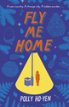 |  | Fly Me Home  by Polly Ho Yen |  |  |  | 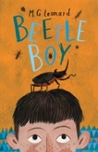 |  | Beetle Boy  by M.G. Leonard
Length |  | 6 weeks |  |  |  |  |  | 6 weeks

Theme/Term |  | Spring 1 |  |  |  |  |  | Spring 2
The Write Stuff Units |  | 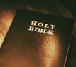 | RE through Literacy:  Christmas | 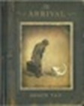 | The Arrival  by Shaun Tan | 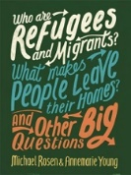 | Who are refugees and migrants?...  by Michael Rosen and Annemarie Young | 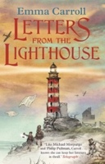 |  | Letters from the Lighthouse  by Emma Carroll |  | RE through Literacy: Holy Week
Length |  | 1 week |  | 3 weeks |  | 1 week |  | 3 weeks |  |  | 2 weeks
Outcomes |  | Main outcomes: Diary entry, newspaper report |  | Main Outcome: Narrative |  | Main Outcome: Formal letter |  | Main Outcome: Recount |  |  | Main Outcome: Informal letter, diary entry
Literary Leaf Text |  | 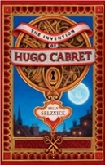 | The Invention of Hugo Cabret  by Brian Selznick |  |  |  |  | 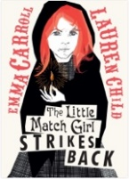 | The Little Match Girl Strikes Back  by Emma Carroll
Length |  | 5 weeks |  |  |  |  |  | 5 weeks

Theme/Term |  | Summer 1 |  |  |  |  | Summer 2
The Write Stuff Units |  | 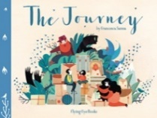 |  | The Journey by Francesca Sanna |  | Real-life experience – visit to Islamic Exhibition Centre | 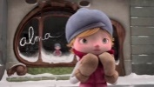 |  | Alma  by Rodrigo Blaas (animation) | 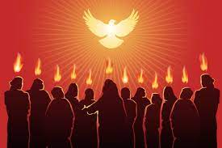 | RE through Literacy  (Pentecost) | 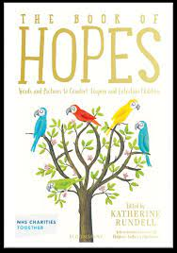 | The Hope-o-potamus  by Greg James and Chris Smith
Length |  | 4 weeks |  |  | 2 weeks |  | 2 weeks |  |  | 1 week |  | 3 weeks
Outcomes |  | Main Outcome: Narrative |  |  | Main Outcome: Non-chronological report |  | Main Outcome: Setting description, dialogue, narrative |  |  | Main Outcome: Newspaper report |  | Main Outcome: Poetry
Literary Leaf Text |  | 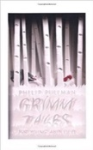 | Grimm Tales for Young and Old  by Phillip Pullman |  |  |  | 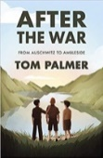 | After the War: From Auschwitz to Ambleside  by Tom Palmer
Length |  | 6 weeks |  |  |  |  | 6 weeks

