Theme/Term | Coming together & community | Ambition & desire Autumn 1 |  |  |  |  |  |  |  |  |  |  |  | Power vs. principles Autumn 2
Planning Sequence/ | The Midnight Panther  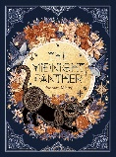 | 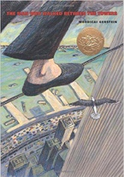  The Man Who Walked Between the Towers  Mordicai Gerstein |  |  |  |  |  |  | 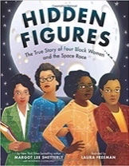  OR Hidden Figures  Margot Lee Shetterly |  |  | Science: Space |  |  |  | 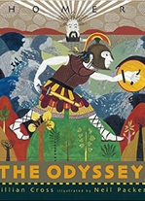  The Odyssey  Gillian Cross |  | History: Ancient Greece | R.E. through Literacy Week |  | History: Ancient Greece
Length | 2 weeks | 12 sessions, 2+ weeks |  | 15 sessions, 3 weeks |  |  |  |  | 17+ sessions, 3+ weeks |  |  |  |  | 14+ sessions, 3 + weeks |  | 20 sessions, 4 weeks |  |  | 20 sessions, 4 weeks
Outcomes | Instructions, poetry, biographies, celebrating uniqueness, slogans and posters. | Biographies/autobiographies  Information writing (Wikipedia pages), letters of advice (formal), interviews, news report, persuasive speeches |  | Science-fiction narratives  Discussions, debates, dialogue, character comparisons, reviews |  |  |  |  | Memoirs  Reports, formal and informal letters, diaries, character descriptions, journalistic writing |  |  |  |  | Playscripts  Setting descriptions, character descriptions, diaries, dialogue |  | Epic stories Speeches (proclamation, persuasive, soliloquy), dialogue, missing scenes, postcards, adverts |  |  | Mythical narratives  Odes, soliloquies, setting descriptions, additional chapters, reports
Literary Leaf Text | 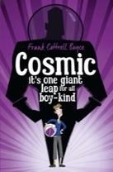  Cosmic Frank Cottrell Boyce |  |  |  |  |  |  |  |  |  |  |  | Science: Space |  |  | 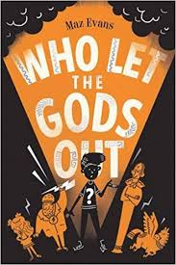  Who Let the Gods Out  Maz Evans |  | History: Ancient Greece |  |  | History: Ancient Greece
Length |  | 15 sessions, 3 weeks |  |  | 19 sessions, 3+ weeks |  |  | 15 sessions, 3 weeks |  |  |  |  |  | 16 sessions, 3+ weeks |  | 14 sessions, 2+ weeks |  |  | 15 sessions, 3 weeks
Theme/Term |  | Belonging & equality Spring 1 |  |  |  |  |  |  |  |  |  |  |  | Legends & folklore Spring 2
Planning Sequence/  Splling Seed Text | 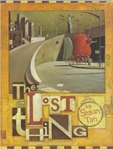  The Lost Thing  Shaun Tan |  |  |  | 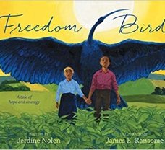  Freedom Bird  Jerdine Nolen |  |  |  |  |  |  |  |  |  |  | 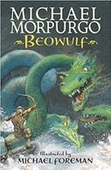  Beowulf  Michael Morpurgo
Length |  | 16 sessions, 3+ weeks |  |  | 15 sessions, 3 weeks |  |  | 15 sessions, 3 weeks |  |  |  |  |  | 17 sessions, 3+ weeks |  | 15 sessions, 3 weeks |  |  | 15 sessions, 3 weeks
Outcomes |  | Own version fantasy narratives  Diaries, formal letters, adverts, character and setting descriptions, non-chronological reports |  |  | Sequel from a different perspective  Welcome guide, description, letter of advice, analysis comparison, diary entry in role, imagined conversation |  |  | Biographies  Writing in role, thought bubbles, dialogue, postcards, recounts, poems |  |  |  |  |  | Fairytale reworkings  Warning posters, diaries, dialogue, estate agent’s descriptions, character descriptions, missing narratives |  | Own version legends/missing chapters Letters of advice, diaries, dialogue, character and setting descriptions, action scenes, obituaries |  |  | Alternative perspective prequels -  Newspaper reports, extended responses to a text
Literary Leaf Text |  |  |  |  |  |  |  | 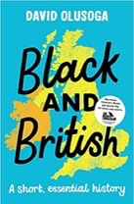  Black and British: A short, essential history  David Olusoga |  |  |  |  | History:  Britain | Black and British: A short, essential history  David Olusoga |  |  |  |  | R.E. through Literacy
Length |  | 15 sessions, 3 weeks |  |  | 15 sessions, 3 weeks |  |  | 15 sessions, 3 weeks |  |  |  |  |  | 12 sessions, 3 weeks |  | 15 sessions, 3 weeks |  |  | 10 sessions, 2 weeks
Theme/Term |  | Lessons from history Summer 1 |  |  |  |  |  |  |  |  |  |  |  | Mystery & truth Summer 2
Planning Sequence/ | 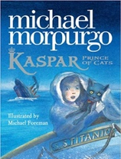  Kaspar, Prince of Cats  Michael Morpurgo |  |  |  |  | History: Benin | 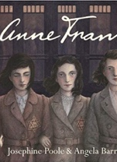  Anne Frank  Josephine Poole |  |  | History:  WW2 |  |  | History:  WW2 | 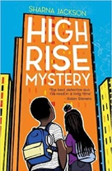  High Rise Mystery  Sharna Jackson |  |  | 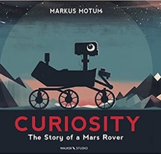  Curiosity  Markus Motum
Length |  | 15 sessions, 3 weeks | 15 sessions, 3 weeks |  |  |  | 10 sessions, 2+ weeks |  |  |  | 10 sessions, 2 weeks |  |  | 15 sessions, 3 weeks | 15 sessions, 3 weeks |  | 15 sessions, 3 weeks |  |  | 10 sessions, 2 weeks
Outcomes |  | Newspaper articles  Character descriptions, reports, letters, advertising leaflets, balanced reports | Non-chronological reports  Informal letters, diaries, survival guides, eyewitness reports, story summaries |  |  |  | Newspaper articles  Letters, short descriptions, extended diary entries, obituaries, opinion pieces |  |  |  | Historical narratives  Character descriptions, missing scenes, newspaper articles |  |  | Extended stories Character & setting descriptions, police & newspaper report, dialogue, persuasive letters | Discussion texts  Instructions, persuasion, diaries |  | Expanded explanations  NASA Proposals, information labels, short explanations, NASA logs, news reports |  |  | Fairytale narratives  Formal letters, retellings, character descriptions
Literary Leaf Text | 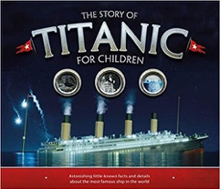  The Story of Titanic for Children Joe Fullman  History:  WW2 |  |  |  |  |  |  |  |  |  |  |  | History:  WW2 | 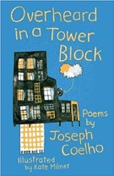  Overheard in a Tower Block  Joseph Coelho |  |  | 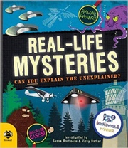  Real-life Mysteries: Can you explain the unexplained?  Susan Martineau and Vicky Barker
Length |  | 15 sessions, 3 weeks |  |  | 15 sessions, 3 weeks |  |  | 15 sessions, 3 weeks |  |  |  |  |  | 10 sessions, 2 weeks |  |  | 15 sessions, 3 weeks

