Theme/Term |  | Autumn 1 |  |  |  |  |  |  | Autumn 2
Writing Root |  | 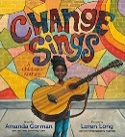 | Change Sings by  Amanda Gorman |  | 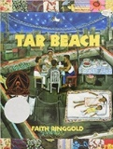 | Tar Beach  by Faith Ringgold | 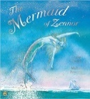 | The Mermaid of Zennor by  Charles Causley | 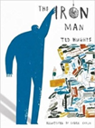 |  | Iron Man by Ted Hughes | 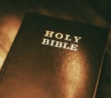 | RE through Literacy: Christmas
Length |  | 2 weeks |  |  | 4 weeks |  | 3 weeks |  | 4 weeks |  |  | 2 weeks
Outcomes |  | Main Outcome: Narrative  Other genres covered:  Poetry, biographies celebrating uniqueness, slogans and posters |  |  | Main Outcome: Own version playscripts  Other genres covered: Character descriptions, formal letters, book reviews, dialogue (direct speech), retellings |  | Main Outcome: Own version legends  Other genres covered: Information booklets, retelling from a different perspective, letters, tourist guides updates, dialogue |  | Main Outcome: Mystery narratives  Other genres covered: Character descriptions, short news reports, letters of advice, menus (using descriptive devices), poetry |  |  | Main Outcome:  Narrative  Other genres covered: Retelling from a different perspective, diary entry, poetry
Literary Leaf Text |  | 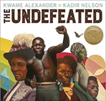 |  | Undefeated by  Kwame Alexander |  |  |  |  | 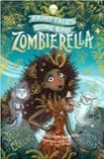 | Zombierella by  Joseph Coelho
Length |  | 6 weeks |  |  |  |  |  |  | 6 weeks

Theme/Term |  | Spring 1 |  |  |  | Spring 2
Writing Root |  | 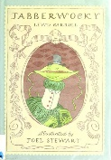 | Jabberwocky by Lewis Carroll | 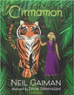 | Cinnamon by Neil Gaiman | 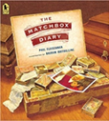 |  | The Matchbox Diary by Paul Fleischman |  | RE through Literacy: Holy Week
Length |  | 2 weeks |  | 3 weeks |  | 3 weeks |  |  | 2 weeks
Outcomes |  | Main outcome: Nonsense poems  Other genres covered: Performance poetry, explanatory descriptions |  | Main Outcome: Own version mythical tales  Other genres covered: Diaries, informal letters, dialogue, adverts, limericks and other poetic forms |  | Main Outcome: Biography  Other genres covered: Dialogue, diary entry, re-telling (oral dictation), mini-autobiography, fact file |  |  | Main Outcome: Diary entry  Other genres covered: Witness statement.
Literary Leaf Text |  | 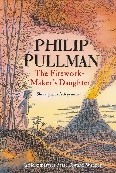 | The Firework Maker’s Daughter by Philip Pullman |  |  | 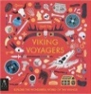 | Viking Voyagers by Jack Tite
Length |  | 5 weeks |  |  |  | 5 weeks

Theme/Term |  | Summer 1 |  |  |  |  | Summer 2
Writing Root |  | 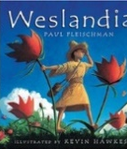 | Weslandia  by Paul Fleischman |  | 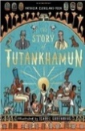 | The Story of Tutankhamun  by Patricia Cleveland-Peck | 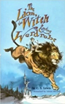 |  | The Lion the Witch and the Wardrobe by C. S. Lewis | 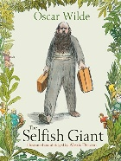 | The Selfish Giant by Oscar Wilde
Length |  | 3 weeks |  |  | 4 weeks |  | 4 weeks |  |  | 3 weeks
Outcomes |  | Main Outcome: Imagined land narratives  Other genres covered: Character description, informative posters, persuasive leaflets, log book |  |  | Main Outcome: Non-chronological reports  Other genres covered: Retelling, character description, book review |  | Main Outcome: Own version narratives (set in other worlds)  Other genres covered: Poems, eyewitness reports, an imaginary conversations, writing in role |  |  | Main Outcome: Own version narratives  Other genres covered: Letters, first person recounts, diaries, letters, posters, reports
Literary Leaf Text |  | 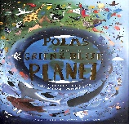 |  | Poems from a Green and Blue Planet by Sabrina Mahfouz |  |  |  | The Lion the Witch and the Wardrobe by C. S. Lewis
Length |  | 6 weeks |  |  |  |  | 6 weeks

