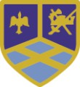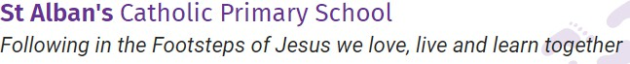
Year Six Curriculum Overview
Autumn Term

Building the Kingdom Catholic Social  Teaching | Family and Community  How do we build rather than destroy God’s kingdom?  Class text: Private Peaceful (Michael Morpurgo)
Big Question | Do people matter more than possessions?
Religious Education  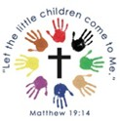 | Our gospel virtues for this term are:  Eloquent & Truthful Learned & Wise  This term’s topics in Religious Education will be:  - Creation and Covenant  Prayers children will learn:  The Apostles Creed The Benedictus
Key Liturgical dates | 1st September – 4th October - The Season of Creation  8th September - Feast of the Nativity of the Blessed Virgin Mary  October, the Month of the Holy Rosary 29th September- 3rd October – St Therese of Lisieux ‘Little Way Week’  9th October - Feast of St John Henry  Newman, Priest | 1st November - All Saints (Holy Day of Obligation)  2nd November- All Souls  29th November – First Sunday of Advent 8th December – The Immaculate Conception
RSE ~ Life to the Full  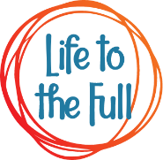 | Module 2 Created to Love Others  Religious Understanding: God is Calling You  Personal Relationships: Under Pressure, Do You Want a Piece of Cake?, Self-Talk, Build Others Up  Life Online: Sharing isn’t Always Caring, Cyberbullying  Keeping Safe: Types of Abuse, Impacted Lifestyles, Making Good Choices, Giving  Assistance.
English  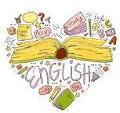 | Class Reading Texts:  After the War, From Auschwitz to Ambleside – Tom Palmer  Writing Text 1:  Private Peaceful – Michael Morpurgo  Writing Outcomes: Character descriptions, setting descriptions, first person narrative  Main outcome: Diary Entry (recount)

Maths  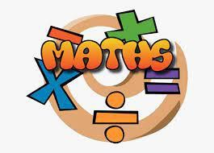 | Place Value  Numbers to 1,000,000  Numbers to 10,000,000  Read and write numbers to 10,000,000 Powers of 10  Number line to 10,000,000 Compare and order any integers Round any integer  Negative numbers  Addition, Subtraction, Multiplication and Division  Add and subtract integers Common factors Common multiples  Rules of divisibility Primes to 100  Square and cube numbers  Multiply up to a 4-digit number by a 2-digit number  Solve problems with multiplication Short division  Division using factors Introduction to long division Long division with remainders Solve problems with division Solve multi-step problems Order of operations  Mental calculations and estimation  Reason from known facts | Fractions A  Equivalent fractions and simplifying Equivalent fractions on a number line Compare and order (denominator) Compare and order (numerator)  Add and subtract simple fractions Add and subtract any two fractions Add mixed numbers  Subtract mixed numbers Multi-step problems  Fractions B  Multiply fractions by integers Multiply fractions by fractions Divide a fraction by an integer Divide any fraction by an integer Mixed questions with fractions Fraction of an amount  Fraction of an amount – find the whole  Converting Units  Metric measures Convert metric measures  Calculate with metric measures Miles and kilometres  Imperial measures
Science  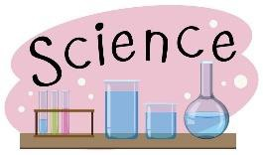 | The Human Body (Biology)  Scientific knowledge and understanding:  - Identify and name the main parts of the human circulatory system, and describe the functions of the heart, blood vessels and blood.  - Describe the ways in which nutrients and water are transported within animals, including humans.  - Recognise the impact of diet, exercise, drugs and lifestyle on the way their bodies function. | Classification of Living Things (Biology)  - Living things are classified into five main kingdoms.  - Cells are tiny building blocks that make up all living things.  - There are two main types of cell: animal and plant.  - Vertebrates are classified into five groups: fish, amphibians, reptiles, birds and mammals.  - Invertebrates are classified into groups, which include insects, arachnids and molluscs.
PE  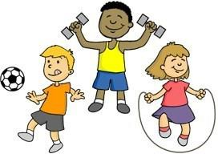 | Stretch and Breathe  - Children will continue to apply and develop a broader range of skills, learning how to use them in different ways and to link them to make actions and sequences of movement.  - Children will develop flexibility, strength, technique, control and balance. | Outdoor and Adventurous Activity (OAA) Pupils should continue to apply and develop a broader range of skills, learning how to use them in different ways and to link them to make actions and sequences of movement.  Children should:  - enjoy communicating, collaborating and competing with each other.  - develop an understanding of how to improve in different physical  activities and sports and learn how

to evaluate and recognise their own success.
- take part in outdoor and adventurous activity challenges
both individually and within a team.
Geography  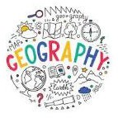 | British Geographical Issues  - To know that the air in many UK cities contains pollution that is harmful to people, plants and animals.  - To know that climate change causes more frequent and severe flooding in the UK.  - To know that in UK we produce millions of tonnes of waste every year from our homes, businesses and industry, managing this waste is a challenge.  - To understand that litter is waste left in open, public spaces. It can cause environmental damage. | North America  - To locate the world’s countries, using maps to focus on Europe (including the location of Russia) and North and South America, concentrating on their environmental regions, key physical and human characteristics, countries, and major cities  - To understand geographical similarities and differences through the study of human and physical geography of a region of the United Kingdom, a region in a European country, and a region within North America.
History  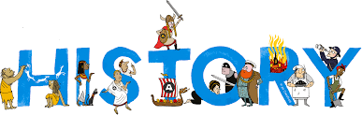 | World War One  - The Causes of World War I  - On land, at sea and in the air  - Life on the Western Front  - The Home Front  - The Consequences of the War | The Suffragettes  - Democracy in the 19th Century  - The National Union of Women’s Suffrage Societies  - Emmeline Pankhurst and the WSPU  - The Anti-Suffrage Campaign  - World War I and the Representation of the People Act
Art   | Art in the Italian Renaissance  Artists: Michelangelo, Leonardo da Vinci, Raphael  Concepts: Italy and ‘rebirth’ (rejection of middle ages), influence of Greek and Roman art, showing humanity and the natural world, anatomical drawings, painting styles – Sfumato, comparison of Leonardo and Michelangelo, realism – linear perspective.  Skills: Observational drawing, using plaster,  designing and painting | Renaissance Architecture and Sculpture Artists/Architects and architecture: Brunelleschi, Donatello, Ghiberti, Michelangelo, Il Duomo, Basilica of St Peter’s  Concepts: Dome design – Il Duomo, relief sculpture, using of linear perspective in sculpture, influence of classical sculpture, idealisation of human form, contrapposto Skills: Sketching architecture – simplifying  forms, designing and creating a relief sculpture in clay - extended project.
Music  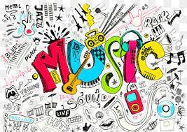 | Unit 1: Metre:  To understand the difference between three and four time. To explore changes in metre.  To explore compound time. To explore irregular metre.  To develop our understanding irregular metre.
Spanish  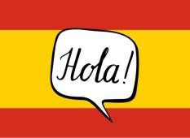 | Unit 1: Así soy yo  - Introducing and describing yourself in Spanish  - Saying your age in Spanish  - Months of the year in Spanish  - Saying the month of your birthday  - Saying your name, age and birthday in Spanish | Unit 2: Dónde vives?  - Saying your nationality  - Saying which country you live in and which language you speak  - Saying which language you don't speak, which country you don't live in and which nationality you aren't  - Saying where you live, your nationality and which language you

 |  | speak
Other key dates | Cultural awareness week beginning 21st September  Little Way Week – Mission – 1st October  Grandparents Day 5th October

